Briefing on Enzymes and Metabolism
Executive Summary
This study guide provides a comprehensive overview of the principles of enzyme function and their central role in metabolism. Enzymes are globular proteins that act as biological catalysts, dramatically increasing the rate of chemical reactions within living organisms by lowering the required activation energy. Their function is intrinsically linked to their three-dimensional structure, particularly the active site, which binds to specific substrates via an induced-fit mechanism. Metabolism is a complex, interdependent network of reactions, broadly categorized into anabolic (synthesis) and catabolic (breakdown) pathways. The rate of enzyme activity is critically influenced by environmental factors such as temperature, pH, and substrate concentration, with effects explained by collision theory and denaturation. This study guide also details the various mechanisms of enzyme inhibition—competitive, non-competitive, feedback, and mechanism-based—which are crucial for the regulation of metabolic pathways. Key examples such as statins, isoleucine, and penicillin are used to illustrate these regulatory processes. The material also distinguishes between intracellular and extracellular reactions, linear and cyclical pathways, and notes the inevitable generation of heat from metabolic processes, which is vital for thermoregulation in many animals.
Key Terms
Active Site
Activation Energy
Allosteric Site
Anabolism
Catabolism
Catalyst
Competitive Inhibition
Condensation Reactions
Denaturation
Enzyme
Enzyme Specificity
Extracellular
Feedback Inhibition
Hydrolysis
Induced-Fit Binding
Inhibitor
Intracellular
Mechanism-based Inhibition
Metabolism
Non-competitive Inhibition
Substrate
- The Fundamental Role of Enzymes in Metabolism
Enzymes are essential for life, serving as biological catalysts that increase the rates of chemical reactions within cells. Their primary function is to facilitate metabolism, which is defined as the complex network of interdependent and interacting chemical reactions occurring in all living organisms.
- Explain how enzymes act as catalysts in metabolic reactions and why they are important.

- Explain why there are so many different enzymes. Relate your explanation to metabolism.

- Enzyme Structure and Catalytic Function
The function of an enzyme is directly determined by its structure as a globular protein.
- Name the region of the enzyme where the reaction takes place.

- Discuss the composition of the enzyme’s active site.

- Discuss the induced-fit model of substrate binding.

- Discuss the lock and key model of substrate binding.

- Discuss the relationship between structure, specificity, and denaturation regarding enzymes.

- The Mechanics of Enzyme Catalysis
Catalysis is a dynamic process that relies on molecular motion and the specific interaction between the substrate and the active site.
- Explain the role of molecular motion to enzyme function.

- Explain how enzymes affect the activation energy of a chemical reaction.

- Core Metabolic Processes: Anabolism and Catabolism
Metabolism is broadly divided into two types of reaction pathways: anabolic and catabolic.
- Define an anabolic reaction and give an example.

  - Examples:

- Define a catabolic reaction and give an example.

  - Examples:

- Factors Influencing Enzyme Activity
The rate of an enzyme-catalyzed reaction is sensitive to several external factors. These effects can be explained with reference to collision theory (the frequency of effective collisions between substrate and active site) and denaturation (the loss of the enzyme's functional shape).
- Explain the effect of temperature on the activity of an enzyme. Sketch a graph depicting at least two different enzymes showing how they are affected by temperature.

- Explain the effect of pH on the activity of an enzyme. Sketch a graph depicting at least two different enzymes showing how they are affected by pH.

- Explain the effect of substrate concentration on the activity of an enzyme. Sketch a graph depicting at least two different enzymes showing how they are affected by substrate concentration.

- Location and Types of Metabolic Pathways
Enzymatic reactions occur in specific locations and can be organized into distinct pathway structures.
- Explain the difference between the following two reaction locations with regard to enzymes and give at least one example of each.
  - Intracellular:

  - Extracellular:

- Describe linear and cyclical pathway structure as it pertains to enzymatic reactions and give an example of each.

  - Examples:

- Metabolism, Energy, and Heat
Metabolic reactions are subject to the laws of thermodynamics, resulting in energy transformations and heat production.
- Explain why some enzymatic reactions generate heat.

- Explain why some enzymatic reactions consume heat.

- Explain how exergonic reactions can help with thermoregulation.

- Mechanisms of Enzyme Inhibition
Enzyme inhibition is a critical mechanism for regulating metabolic pathways. Inhibitors are substances that reduce or stop enzyme activity.
- Complete the following table:
Inhibition Type | Binding Site | Mechanism | Reversibility | Example
Competitive
Non-Competitive
Feedback
Mechanism-Based

- Explain penicillin resistance with regard to changes in the enzyme.

- Pedagogical Focus and Skills Application
The study of this topic emphasizes the development of specific analytical and practical skills.
- You are expected to be able to determine the rate of a chemical reaction. Using the following data, calculate the rate of the reaction. This will be revisited in the lab.

- Graphical Analysis: A key skill is the interpretation of graphs showing the effects of temperature, pH, substrate concentration, and activation energy on enzyme activity.
The graph shows a typical effect of temperature on the reaction rate of a reaction controlled by an enzyme. For the figure below, explain how temperature affects an enzyme activity. Does temperature always have this effect on an enzyme? Explain.

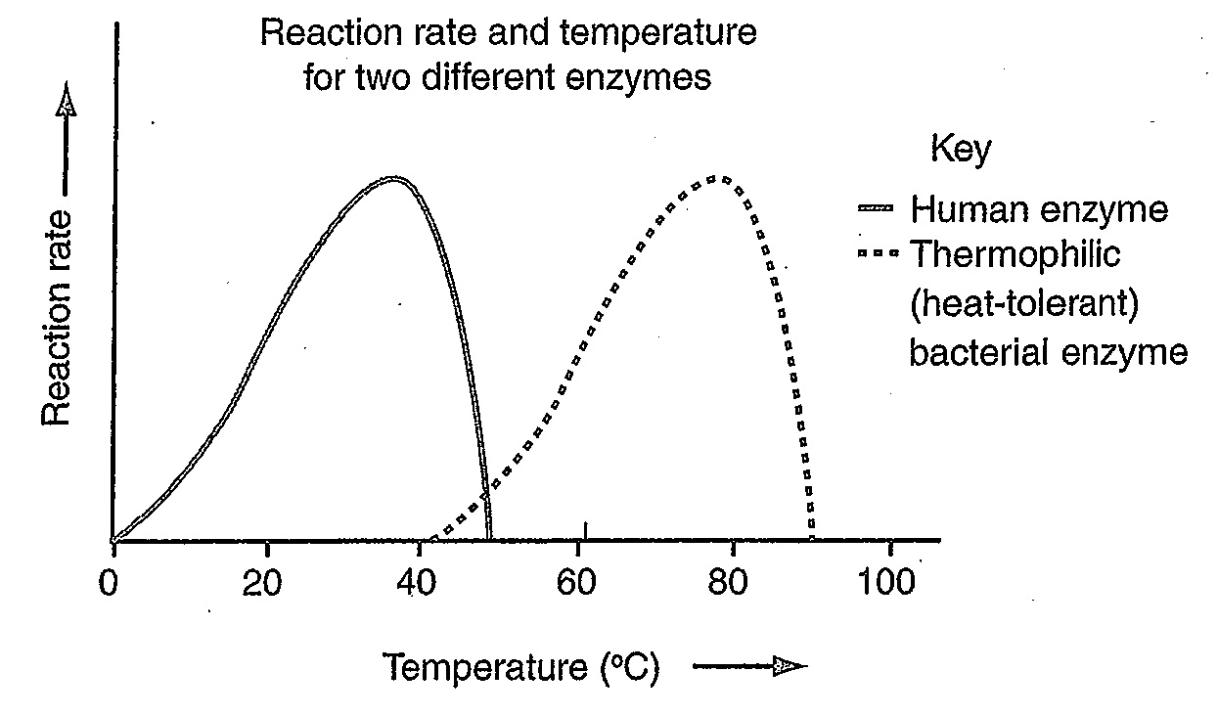

- Modeling in Biology: Using what you’ve learned in this chapter, sketch a graph that represent the effect of pH on the function of an enzyme.

Short-Answer Quiz
Directions: Answer the following questions in 2-3 complete sentences.
- What is the primary benefit of enzymes acting as catalysts within living cells?
- Explain the key difference between anabolic and catabolic reactions, providing an example for each.
- Describe the induced-fit model of enzyme-substrate binding.
- How do temperature and pH affect the rate of enzyme activity?
- What effect do enzymes have on the activation energy of a reaction?
- Distinguish between intracellular and extracellular enzyme-catalyzed reactions, citing an example of each.
- What is competitive inhibition, and how does it differ from non-competitive inhibition in terms of inhibitor binding?
- Explain the mechanism of allosteric regulation and its effect on an enzyme's active site.
- Describe the process of feedback inhibition, using the isoleucine pathway as an example.
- How does mechanism-based inhibition, such as that caused by penicillin, differ from other forms of inhibition?

Essay Questions
Directions: Formulate a detailed response to the following prompts, integrating concepts and examples from class.
- Discuss the critical relationship between the three-dimensional structure of an enzyme, its active site, enzyme-substrate specificity, and the process of denaturation.
- Compare and contrast the mechanisms of competitive, non-competitive, and mechanism-based inhibition. For each type, explain the site of inhibitor binding, the reversibility of the interaction, and provide a specific example.
- Using collision theory, explain how temperature, pH, and substrate concentration each impact the rate of an enzyme-catalyzed reaction. Interpret how these relationships are typically represented in sketch graphs, and discuss the value of such graphs as models in biology.
- Describe how metabolic pathways, such as glycolysis and the Krebs cycle, are organized. Explain the role of feedback inhibition in regulating these pathways and maintaining metabolic balance within an organism.
- Elaborate on the concept of metabolism as a complex network of interdependent reactions. Distinguish between its anabolic and catabolic components, detailing the types of reactions (e.g., condensation, hydrolysis) and specific biological processes involved in each.
- Describe the ways in which enzymes interact with other molecules?
- Explain the interdependent components of metabolism?
- Explain the relative advantages of specificity and versatility in terms of enzymes?
- Drawing upon what you’ve learned about enzymes explain some examples of structure–function relationships in biological macromolecules?
- List some biological processes that depend on differences or changes in concentration?

